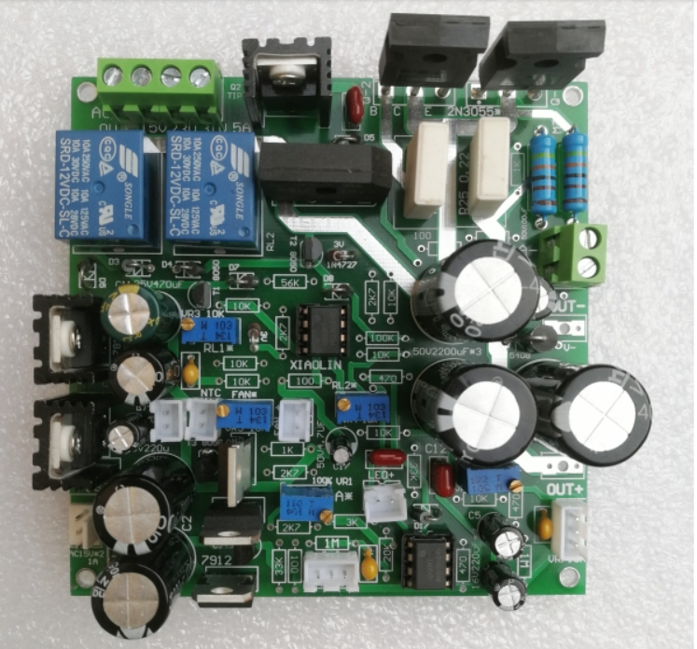**This like the board that I received, BUT, where are the resistors?**